**INTRODUCTION**

Report for Google Data Analytics Capstone Project

**ASK PHASE**

You are a junior data analyst working on the marketing analyst team at Bellabeat, a high-tech manufacturer of health-focused products for women. Bellabeat is a successful small company, but they have the potential to become a larger player in the global smart device market. Urška Sršen, cofounder and Chief Creative Officer of Bellabeat, believes that analyzing smart device fitness data could help unlock new growth opportunities for the company. You have been asked to focus on one of Bellabeat’s products and analyze smart device data to gain insight into how consumers are using their smart devices. The insights you discover will then help guide marketing strategy for the company. You will present your analysis to the Bellabeat executive team along with your high-level recommendations for Bellabeat’s marketing strategy.

Business Task

To analyze smart device usage data in order to gain insight into how consumers use non-Bellabeat smart devices.

Stake Holders

* Urška Sršen: Bellabeat’s cofounder and Chief Creative Officer.
* Sando Mur: Mathematician and Bellabeat’s cofounder; key member of the Bellabeat executive team.
* Bellabeat marketing analytics team: A team of data analysts responsible for collecting, analyzing, and reporting data that helps guide Bellabeat’s marketing strategy.

**PREPARE PHASE**

In this phase we would look at the credibility and integrity of data. And look if it is organised or not.

Data source

Dataset on Kaggle: Fitbit fitness tracker data.

<https://www.kaggle.com/arashnic/fitbit>

We will now use ROCCC method to check the quality of the data.

* RELIABLE: As the dataset only contain data from 30 users we cannot say it is reliable.
* ORIGINAL: The data is obtained from third party (amazon mechanical turk).
* COMPREHENSIVE: As it is data related to smart devices we can say it is relatable to bellabeat products.
* CURRENT: This data is of 2016, so it is quite outdated.
* CITED: Third party data so unknown.

**PROCESS PHASE**

Tools used: SQL, Google spreadsheets

* We explore the data, look for the distinct IDs.
* Check for missing values and incorrect data
* Convert into necessary data types

**ANALYZE PHASE**

Tools used: SQL

* Import the data.
* Explore the data, look at the total number of rows, distinct values, maximum, minimum, or mean values.
* Use JOIN statements to combine your relevant data into different tables based upon the needs of your analyses.
* Create summary statistics.
* Investigate interesting trends and save that information to a table.

**SHARE PHASE**

Tools used: Tableau, Google sheets.First we look at how users spent most of their time, based on the tracked activities.

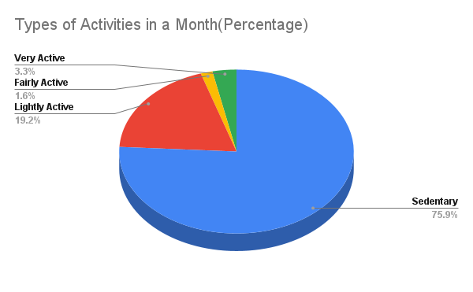

We found that most of the time users spent was in sedentary activities. Followed by Lightly active, then fairly active and at last very active activities.

Next we look at the relation between the tracked calories and steps.

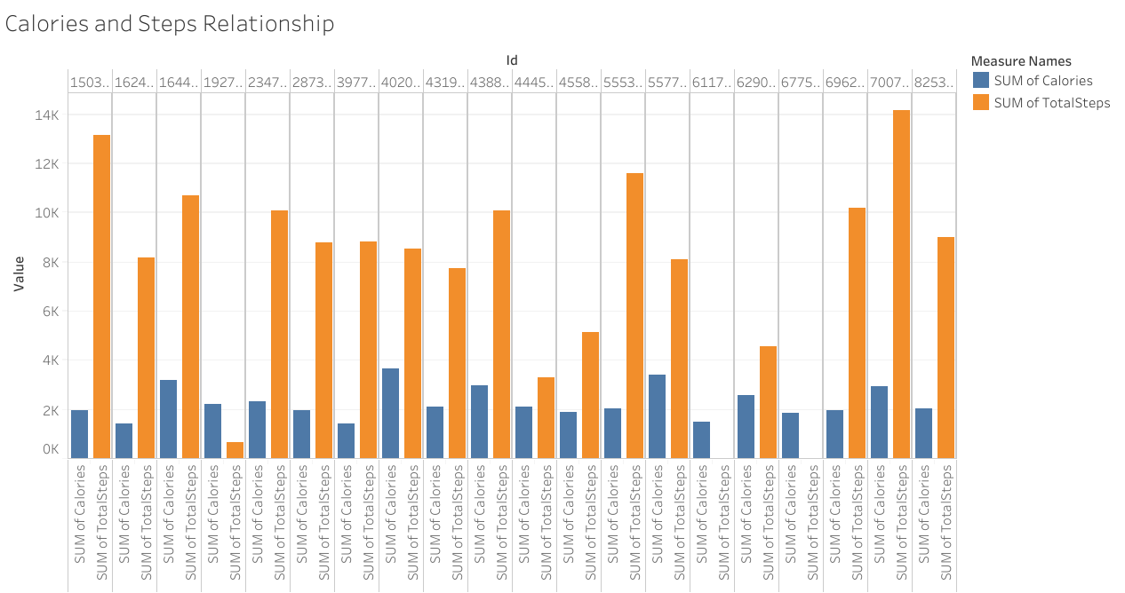

In some users we can see calories but no steps count. We can say that some users don’t track steps.

Relationship between the tracked Sleep and Calories.

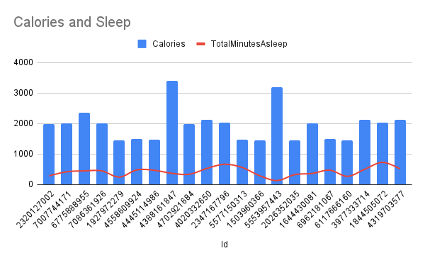

We observe no clear relation between calories and sleep.

**ACT PHASE**

* What is your final conclusion based on your analysis?

1. We find that most of the time spent are on sedentary activities.
2. We find that some users do not track their steps.

* How could your team and business apply your insights?

We can improve technology to get more accurate measure of the sedentary activities. Also we could improve devices to track steps all the time and not just depend on manual tracking.

* What next steps would you or your stakeholders take based on your findings?

Bellabeat can decide to modify their device based on these findings.

Recommendations for the marketing team:

Design a strategy involving automatic products which tracks automatically rather than manual. Also that their products measures every activity efficiently, be it sedentary, light active or very active.